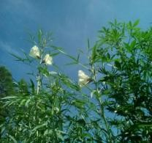
ZHANGPU ZHONGLONG KENAF SEEDS CO.,LTD |  | Mobile: 0086-15695966658  Mobile: 0086 18959620286  TEL:0086 596 3215898  Email: cnkenafseed@gmail.com
Address: No.140, Dongsheng Road,Shuian town,Zhangpu County,Fujian province, China
Address in Chinese: 福建省漳浦县绥安镇东胜路 140 号

QUOTE OF THE HEMP TOWER CLEAN MACHINE
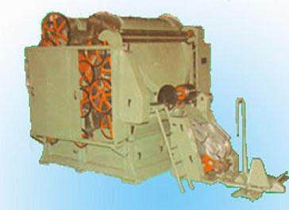 |  | Bank : CHINA CONSTRUCTION BANK CORP ZHANGZHOU BR.  A/C: ZHANGPU ZHONGLONG KENAF SEEDS CO.,LTD  A/C No. :35050166730700000014 SWIFT CODE：PCBCCNBJFJZ  Intermediary Bank: BANK OF AMERICA,NEW YORK(BOFAUS3N )  CHINA CONSTRUCTION BANK HONGKONG BR.(SWIFT :PCBCHKHH)  JP MORGAN CHASE BANK N.A.NEW  YORK(SWIFT:CHASUS33)
Name:. | Description |  | Quantity |  | Unit  price | Amount
ZL-5 HEMP FIBER CARDER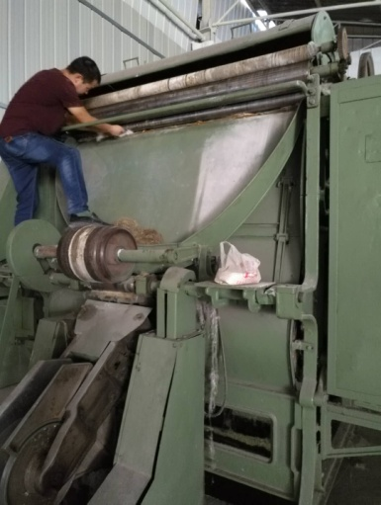 | SIZE:950*230*330CM  Weight 12 TONS  Feeding part:  7*2.2*3.3meter  Procession speed: 400-500 kilos fiber per one hour  Function:Work as carding machine and cleaning machine for fiber out of the soft fiber machine |  | Each 1 Unit |  | $21500 | $21500
Totally 12000KILO | With Freight to Destination Port via Sea Freight
 |  |  |  | TOTAL |  | $21500

